# Operating System - Services

**An Operating System provides services to both the users and to the programs.**

* It provides programs an environment to execute.
* It provides users the services to execute the programs in a convenient manner.

Following are a few common services provided by an operating system −

* Program execution
* I/O operations
* File System manipulation
* Communication
* Error Detection
* Resource Allocation
* Protection

**Program execution**

Operating systems handle many kinds of activities from user programs to system programs like printer spooler, name servers, file server, etc. Each of these activities is encapsulated as a process.

A process includes the complete execution context (code to execute, data to manipulate, registers, OS resources in use). Following are the major activities of an operating system with respect to program management −

* Loads a program into memory.
* Executes the program.
* Handles program's execution.
* Provides a mechanism for process synchronization.
* Provides a mechanism for process communication.
* Provides a mechanism for deadlock handling.

**I/O Operation**

An I/O subsystem comprises of I/O devices and their corresponding driver software. Drivers hide the peculiarities of specific hardware devices from the users.

An Operating System manages the communication between user and device drivers.

* I/O operation means read or write operation with any file or any specific I/O device.
* Operating system provides the access to the required I/O device when required.

**File system manipulation**

A file represents a collection of related information. Computers can store files on the disk (secondary storage), for long-term storage purpose. Examples of storage media include magnetic tape, magnetic disk and optical disk drives like CD, DVD. Each of these media has its own properties like speed, capacity, data transfer rate and data access methods.

A file system is normally organized into directories for easy navigation and usage. These directories may contain files and other directions. Following are the major activities of an operating system with respect to file management −

* Program needs to read a file or write a file.
* The operating system gives the permission to the program for operation on file.
* Permission varies from read-only, read-write, denied and so on.
* Operating System provides an interface to the user to create/delete files.
* Operating System provides an interface to the user to create/delete directories.
* Operating System provides an interface to create the backup of file system.

**Communication**

In case of distributed systems which are a collection of processors that do not share memory, peripheral devices, or a clock, the operating system manages communications between all the processes. Multiple processes communicate with one another through communication lines in the network.

The OS handles routing and connection strategies, and the problems of contention and security. Following are the major activities of an operating system with respect to communication −

* Two processes often require data to be transferred between them
* Both the processes can be on one computer or on different computers, but are connected through a computer network.
* Communication may be implemented by two methods, either by Shared Memory or by Message Passing.

**Error handling**

Errors can occur anytime and anywhere. An error may occur in CPU, in I/O devices or in the memory hardware. Following are the major activities of an operating system with respect to error handling −

* The OS constantly checks for possible errors.
* The OS takes an appropriate action to ensure correct and consistent computing.

**Resource Management**

In case of multi-user or multi-tasking environment, resources such as main memory, CPU cycles and files storage are to be allocated to each user or job. Following are the major activities of an operating system with respect to resource management −

* The OS manages all kinds of resources using schedulers.
* CPU scheduling algorithms are used for better utilization of CPU.

**Protection**

Considering a computer system having multiple users and concurrent execution of multiple processes, the various processes must be protected from each other's activities.

Protection refers to a mechanism or a way to control the access of programs, processes, or users to the resources defined by a computer system. Following are the major activities of an operating system with respect to protection −

* The OS ensures that all access to system resources is controlled.
* The OS ensures that external I/O devices are protected from invalid access attempts.
* The OS provides authentication features for each user by means of passwords.

**Operating System - Properties**

Following are the different properties of an Operating System. This tutorial will explain these properties in detail one by one:

1. Batch processing
2. Multitasking
3. Multiprogramming
4. Interactivity
5. Real Time System
6. Distributed Environment
7. Spooling

**Batch processing**

Batch processing is a technique in which an Operating System collects the programs and data together in a batch before processing starts. An operating system does the following activities related to batch processing −

* The OS defines a job which has predefined sequence of commands, programs and data as a single unit.
* The OS keeps a number a jobs in memory and executes them without any manual information.
* Jobs are processed in the order of submission, i.e., first come first served fashion.
* When a job completes its execution, its memory is released and the output for the job gets copied into an output spool for later printing or processing.

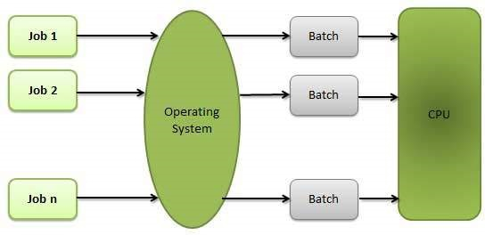

Advantages

* Batch processing takes much of the work of the operator to the computer.
* Increased performance as a new job get started as soon as the previous job is finished, without any manual intervention.

Disadvantages

* Difficult to debug program.
* A job could enter an infinite loop.
* Due to lack of protection scheme, one batch job can affect pending jobs.

**Multitasking**

Multitasking is when multiple jobs are executed by the CPU simultaneously by switching between them. Switches occur so frequently that the users may interact with each program while it is running. An OS does the following activities related to multitasking −

* The user gives instructions to the operating system or to a program directly, and receives an immediate response.
* The OS handles multitasking in the way that it can handle multiple operations/executes multiple programs at a time.
* Multitasking Operating Systems are also known as Time-sharing systems.
* These Operating Systems were developed to provide interactive use of a computer system at a reasonable cost.
* A time-shared operating system uses the concept of CPU scheduling and multiprogramming to provide each user with a small portion of a time-shared CPU.
* Each user has at least one separate program in memory.

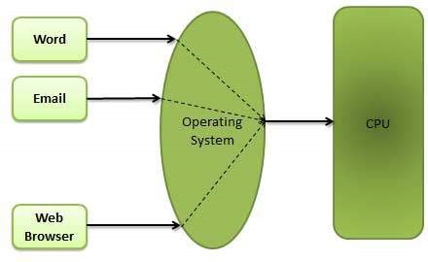

* A program that is loaded into memory and is executing is commonly referred to as a **process**.
* When a process executes, it typically executes for only a very short time before it either finishes or needs to perform I/O.
* Since interactive I/O typically runs at slower speeds, it may take a long time to complete. During this time, a CPU can be utilized by another process.
* The operating system allows the users to share the computer simultaneously. Since each action or command in a time-shared system tends to be short, only a little CPU time is needed for each user.
* As the system switches CPU rapidly from one user/program to the next, each user is given the impression that he/she has his/her own CPU, whereas actually one CPU is being shared among many users.

**Multiprogramming**

Sharing the processor, when two or more programs reside in memory at the same time, is referred as **multiprogramming**. Multiprogramming assumes a single shared processor. Multiprogramming increases CPU utilization by organizing jobs so that the CPU always has one to execute.

The following figure shows the memory layout for a multiprogramming system.

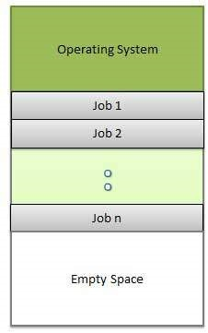

An OS does the following activities related to multiprogramming.

* The operating system keeps several jobs in memory at a time.
* This set of jobs is a subset of the jobs kept in the job pool.
* The operating system picks and begins to execute one of the jobs in the memory.
* Multiprogramming operating systems monitor the state of all active programs and system resources using memory management programs to ensures that the CPU is never idle, unless there are no jobs to process.

Advantages

* High and efficient CPU utilization.
* User feels that many programs are allotted CPU almost simultaneously.

Disadvantages

* CPU scheduling is required.
* To accommodate many jobs in memory, memory management is required.

**Interactivity**

Interactivity refers to the ability of users to interact with a computer system. An Operating system does the following activities related to interactivity −

* Provides the user an interface to interact with the system.
* Manages input devices to take inputs from the user. For example, keyboard.
* Manages output devices to show outputs to the user. For example, Monitor.

The response time of the OS needs to be short, since the user submits and waits for the result.

**Real Time System**

Real-time systems are usually dedicated, embedded systems. An operating system does the following activities related to real-time system activity.

* In such systems, Operating Systems typically read from and react to sensor data.
* The Operating system must guarantee response to events within fixed periods of time to ensure correct performance.

**Distributed Environment**

A distributed environment refers to multiple independent CPUs or processors in a computer system. An operating system does the following activities related to distributed environment −

* The OS distributes computation logics among several physical processors.
* The processors do not share memory or a clock. Instead, each processor has its own local memory.
* The OS manages the communications between the processors. They communicate with each other through various communication lines.

**Spooling**

Spooling is an acronym for simultaneous peripheral operations on line. Spooling refers to putting data of various I/O jobs in a buffer. This buffer is a special area in memory or hard disk which is accessible to I/O devices.

An operating system does the following activities related to distributed environment −

* Handles I/O device data spooling as devices have different data access rates.
* Maintains the spooling buffer which provides a waiting station where data can rest while the slower device catches up.
* Maintains parallel computation because of spooling process as a computer can perform I/O in parallel fashion. It becomes possible to have the computer read data from a tape, write data to disk and to write out to a tape printer while it is doing its computing task.

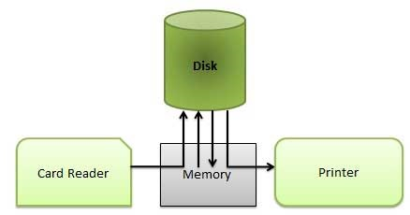

Advantages

* The spooling operation uses a disk as a very large buffer.
* Spooling is capable of overlapping I/O operation for one job with processor operations for another job.